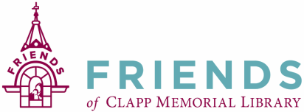

Friends of the Clapp Memorial Library Annual Meeting— November 14, 2019

The annual meeting of the Friends of Clapp Memorial Library (FCML) was called to order by Meredith Weiss, Vice-President at 7:08pm. Members signed in on an attendance sheet which will be attached to the official copy of the minutes.

- Message from the President: A heartfelt thanks from Paul Geoffroy to all FCML board members and dedicated volunteers for their help and hard work throughout the year.
There have been many, many FCML activities and projects funded this year including:
- Library Operating Budget
- Heating and Cooling System
- Condenser
- Insurance
- Love Your Library event.
- Parade Float
- Internet Support
- New computers at circulation desk
- Elevator maintenance
- Summer reading program
- 35 unique one-time programs in addition to regular programs such as book clubs and others

- A motion made to accept the minutes from the October 2019 Annual Meeting as amended. Seconded and approved.

- Job Descriptions: Descriptions are complete and filed with the July, 2019 minutes.

- The Friends Board: Open positions are President, Recording Secretary, and three at-large members.
Procedures to nominate and vote in candidates were followed and resulted in the following:
- President, two-year term: Paul Geoffroy
- Recording Secretary, two-year term: Martha DuroShea
- At-Large Members, one-year term: Gary Ewing, Mike Hoffler, Jim Knittel

- Publicity Coordinator. Kelly Edreich will take on this position. Publicity contact lists will be updated.

Meeting adjourned at 7:36 pm.

Minutes respectfully submitted by Martha DuroShea, Recording Secretary.

Next monthly meeting on Thursday, January 9, 2020 at 6:30

