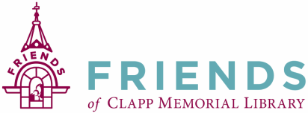

Friends of the Clapp Memorial Library Monthly Meeting— February 16, 2023

A meeting of the Friends of Clapp Memorial Library (FCML) was called to order at 6:30pm by Paul Geoffroy. Members signed in on an attendance sheet which will be attached to the official copy of the minutes.

- Treasurer’s Report was presented by Brian Mailhot, Treasurer. Report dated 1/19/2023.
- Minutes from the January 2023 meeting were reviewed and accepted by unanimous vote.

Old Business
- Need publicity person for future book sales.
- Lisa Aiken has volunteered to do publicity for the book sale. Deb Comeau will assist Lisa. They will set up a system for a new publicity person to work with.
- A motion was made to donate the total book sale revenue from December 2022 to the library. A donation to the library was made in the amount of $15,744.60. Check was presented to the Trustees.
New Business:
- Wine Tasting Event:
  - The wine is purchased and the descriptions for each type have been written.
  - We have enough volunteers.
  - Add a table for wine related books. (Self-serve sales).
- Idea/Discussion about having a beer tasting event with independent brewers. Include Belchertown beer brewer Arcpoint.
- Director’s Report - Cynthia Harbeson:
  - Trustees appreciate the FCML donation.
  - Discussion about moving chairs, bookcases, and potentially other items in the basement and hallway. Details to follow after spring book sale.

Meeting adjourned at 7:14 pm.
Minutes respectfully submitted by Martha DuroShea, Recording Secretary.
Next Meeting will be March 16, 2023 at 6:30pm

