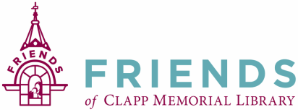

Friends of the Clapp Memorial Library Monthly Meeting— October 19, 2018

A meeting of the Friends of Clapp Memorial Library (FCML) was called to order by Meredith Weiss, Interim Vice-President at 6:31pm. Members signed in on an attendance sheet which will be attached to the official copy of the minutes.

1. Treasurer’s Report was presented by Brian Mailhot, Treasurer.

2. Meeting Minutes
A: Motion made to accept the September 2018 meeting minutes as submitted. Seconded and unanimously approved.

3. Old Business

A: Friends Brochure: Is PayPal something that should be listed on the brochure? Other minor edits suggested. Send further comments/suggestions to Meredith within the next month. Final copy will be ready to present at November meeting.

4. New Business
A. The Booksale and Bake Sale were a huge success
B. Discover Books is coming for clean-out on Saturday, October 27th 8:00-11:00am. More volunteers are needed.
C. The FCML Bulletin Board in the library is being updated regularly.
D. HVAC Basement timeline: Begin November 19th – probably a 2-week job, (dates subject to change.) First part of project will be in the basement removing furnace and ductwork. Following week will be in the Children’s Room. Mauri would like to meet with project manager to discuss logistics.

Meeting adjourned at 6:50pm.

Minutes respectfully submitted by Martha DuroShea, Recording Secretary.

Next monthly meeting on Thursday November 8, 2018

